Hands On Steps:

1. Create a new react application using *create-react-app* tool with the name as “blogapp”
2. Open the application using VS Code
3. Create a new file named as **Post.js** in **src folder** with following properties

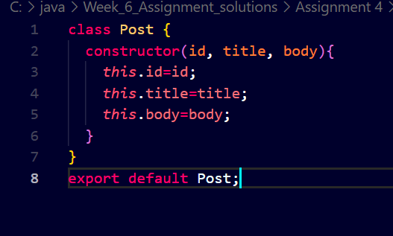

1. Create a new class based component named as **Posts** inside **Posts.js** file and code the following:
2. Initialize the component with a list of Post in state of the component using the constructor

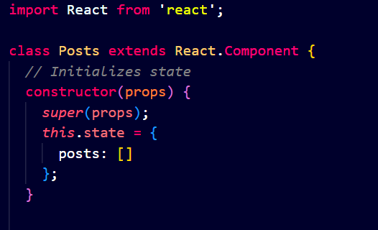

1. Create a new method in component with the name as **loadPosts()** which will be responsible for using Fetch API and assign it to the component state created earlier. To get the posts use the url (<https://jsonplaceholder.typicode.com/posts>)

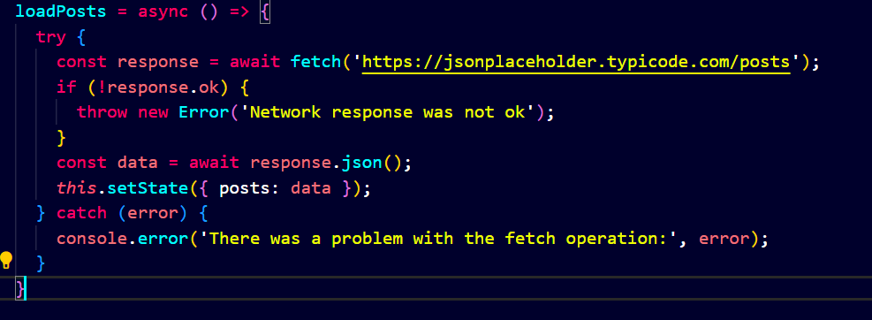

1. Implement the **componentDidMount()** hook to make calls to **loadPosts()** which will fetch the posts
2. Implement the **render()** which will display the title and post of posts in html page using heading and paragraphs respectively.
3. Define a **componentDidCatch()** method which will be responsible for displaying any error happing in the component as alert messages.

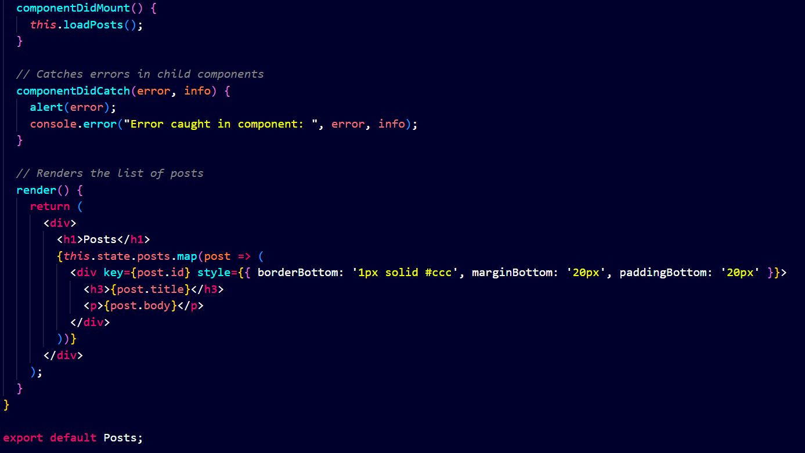

Figure 7: componentDidCatch() hook

1. Add the Posts component to App component.

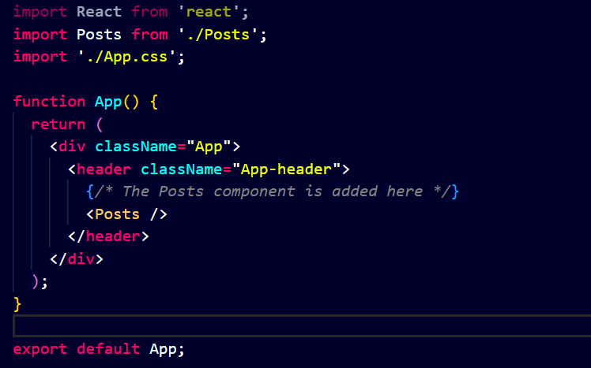

1. Build and Run the application using *npm start* command.

